[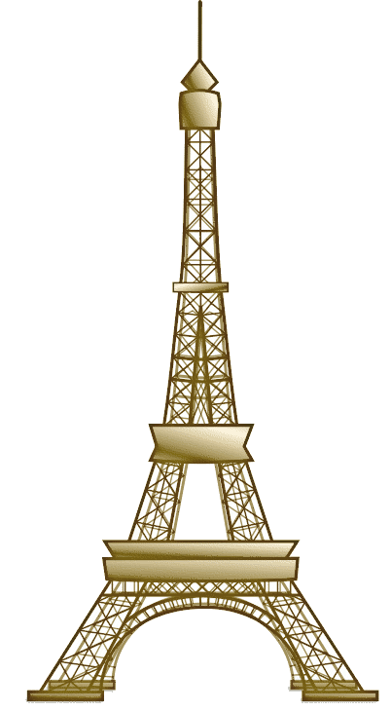](http://www.google.com/url?sa=i&rct=j&q=&source=images&cd=&cad=rja&docid=5_i-LRE3Q9YKNM&tbnid=2O7-twtduFCUVM:&ved=0CAUQjRw&url=http%3A%2F%2Fwww.wpclipart.com%2Fbuildings%2Ffamous%2FEiffel_Tower%2FEiffel_Tower_2.png.html&ei=7xbCUbrrE_Pb4AOv54GYBA&bvm=bv.48175248,d.dmg&psig=AFQjCNFMvJCuUMZ5WtycD_QF7Da6OM_POg&ust=1371760732727497)